OOP

Assignment No. 2

**Muhammad Junaid Ali**

**290927**

**BEE-11D**

**Code:**

**Headers.h**



**Instructor.h**



**Instructor.cpp**







**Lecturer.h**



**Lecturer.cpp**





**GradStudent.h**



**GradStudent.cpp**





**Faculty.h**



**Faculty.cpp**





**Main.cpp**



**Screenshots**

**For Lecturer**

Entering Name, Age, and Eccentricity.  
p to receive email and x to break the loop.

Status is being shown as well.

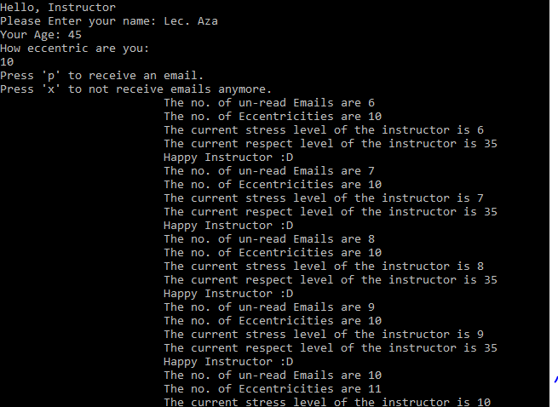

Eccentricity changed randomly by 1

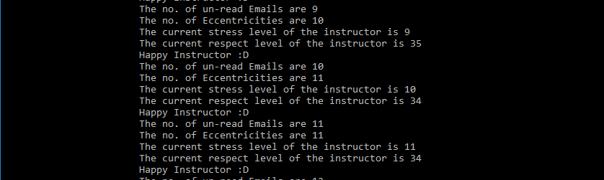

The lecturer’s been Unhappy for a while now and Only the coping mechanism is hit and the stress levels are not reset this time. So only the Email’s are ½ not the stress level.

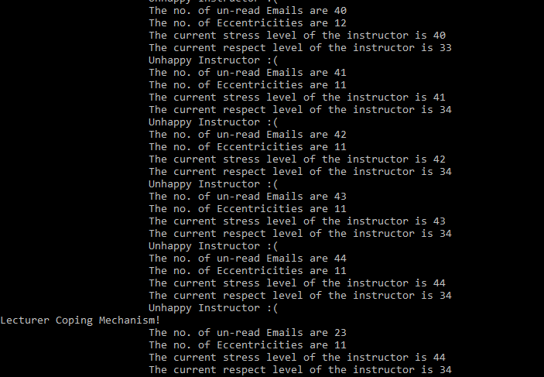

After another batch of mails, this time Coping as well as the Reset function got hit. So stress and no. of Emails are turned to half.

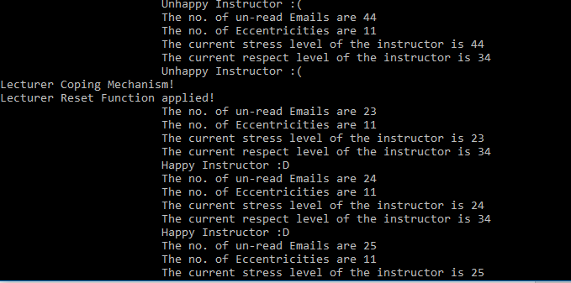

**For Faculty**

Entering Name, Age, and Eccentricity.  
p to receive email and x to break the loop.

Status is being shown as well

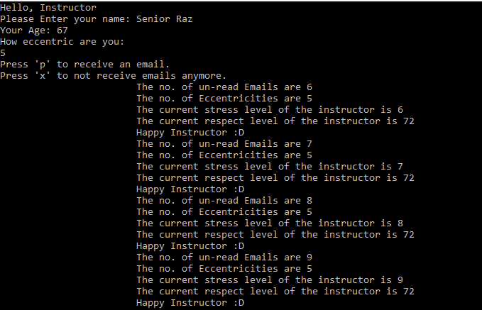

Coping mechanism got hit, so Eccentricity increased by 10 but respect didn’t.

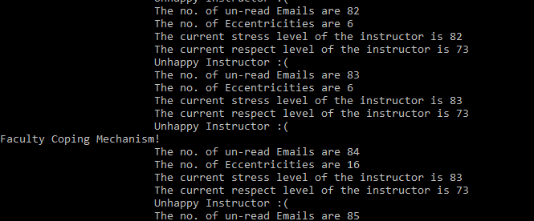

Getting a few more mails in the unhappy condition, this time both of the mechanism hit so respect and eccentricity both increased by 10

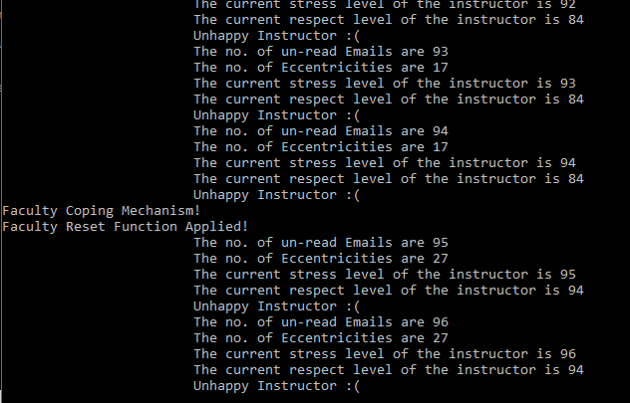

**For GradStudent**

Entering Name, Age, and Eccentricity.  
p to receive email and x to break the loop.

Status is being shown as well

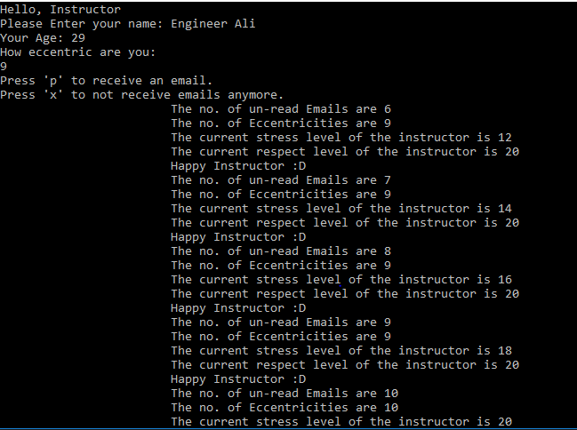

After batch of mails, both the coping mechanism as well as reset function applied so Stress is also turned back down and the no. of unread email turned to zero.

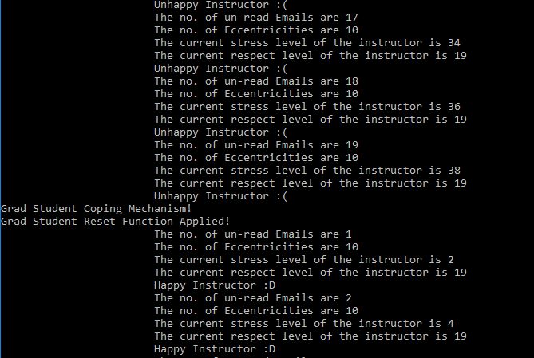

Also the eccentricity went up by one for this case!

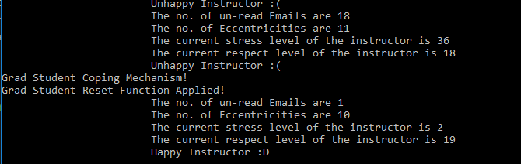

Eccentricity went down in this case.

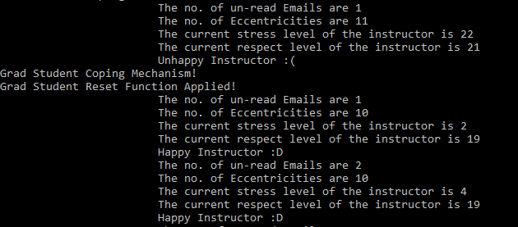

If only the coping mechanism is hit, the stress level remains the same while the unread emails become zero for a grad student.

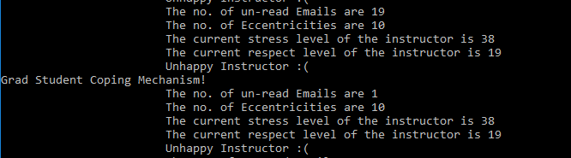

The eccentricity increases by one as well.

